WASH YOUR HANDS / [your text here]
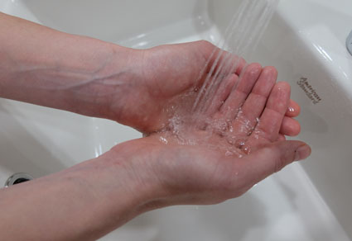
BEFORE RETURNING TO WORK / [your text here]
1 | 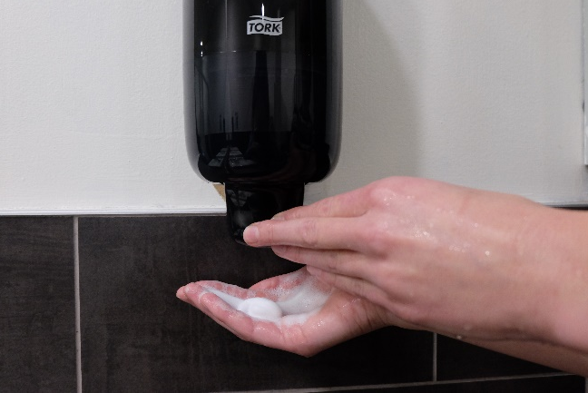  2 |  | 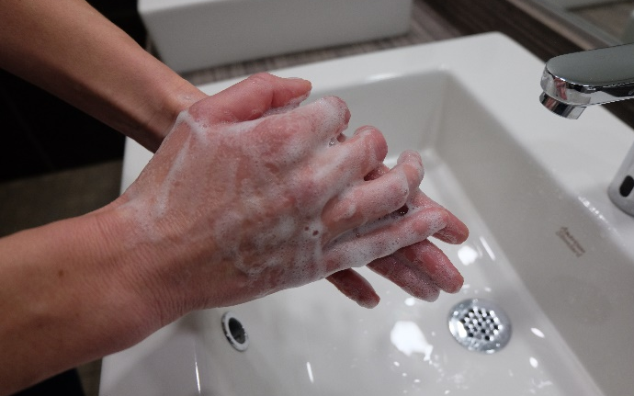  3
Wet hands with potable water  [your text here] |  | Dispense soap  [your text here] |  | Lather soap for 20 seconds  [your text here]
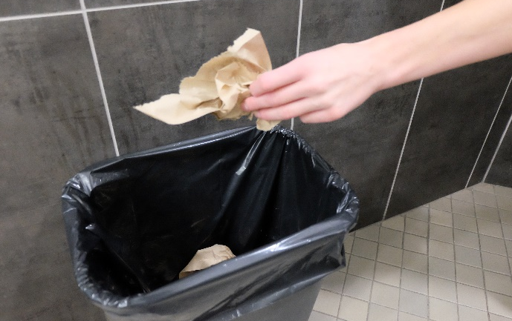
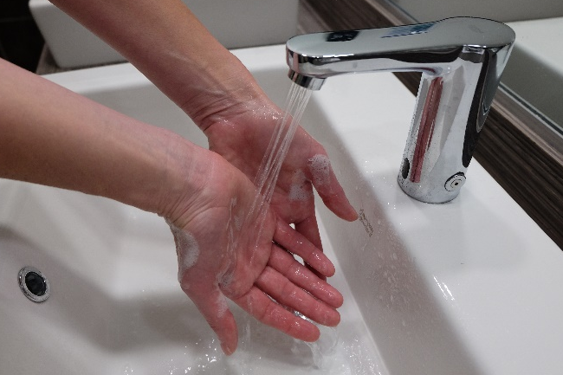  4 | 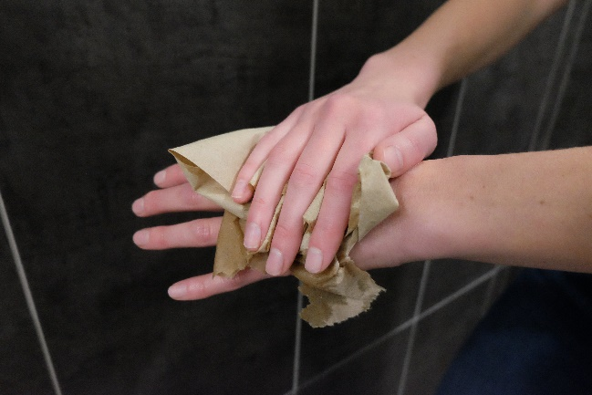  5 |  | 6
Rinse  [your text here] |  | Dry hands with disposable paper towel  [your text here] | 6 | Put paper towel in the garbage  [your text here]

