WASH YOUR HANDS / [your text here]
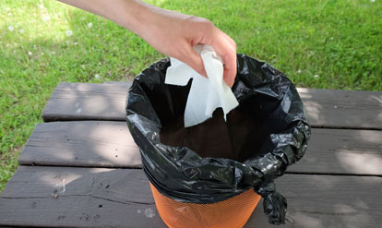
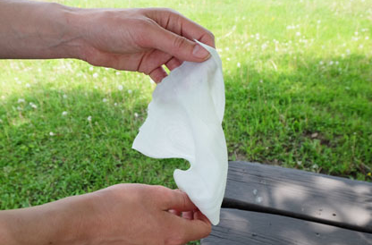
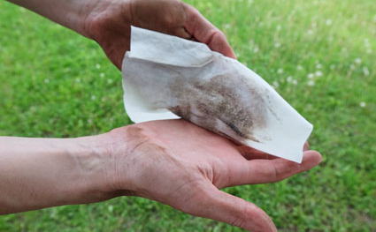
BEFORE RETURNING TO WORK / [your text here]
1 | 2 |  | 3
Use hand wipes  [your text here] | 2 | Remove soil, organic matter, juice, sunscreen, etc.  [your text here] | 3 | Put hand wipe in the garbage  [your text here]
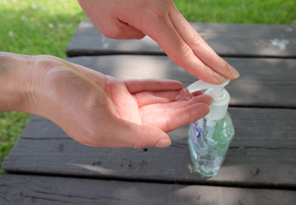  4 | 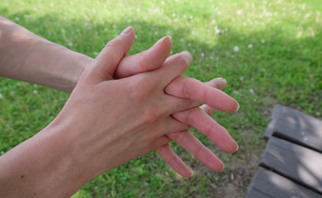 | 5 | 6 | 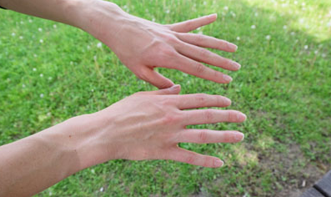
Use one squirt of hand sanitizer  [your text here] |  | Rub all over front and back of hands, wrists and fingernails  [your text here] | 6 | Allow hands to dry  [your text here]

