WASH YOUR HANDS / [your text here]
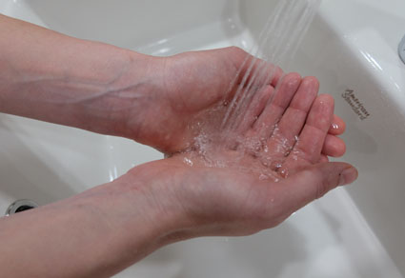
BEFORE RETURNING TO WORK / [your text here]
1 | 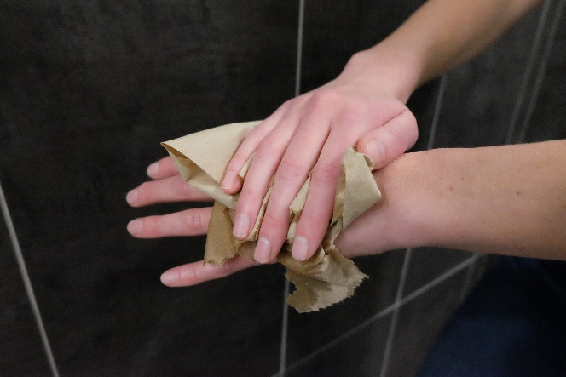  2 |  | 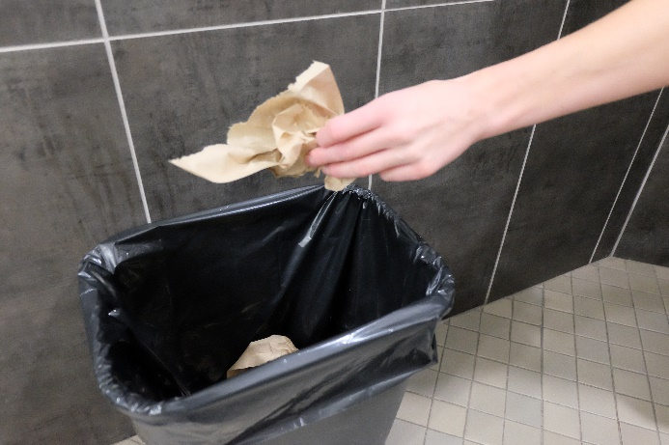  3 | (image)
Wet hands  [your text here] |  | Dry hands with disposable paper towel  [your text here] |  | Put paper towel in the garbage  [your text here]
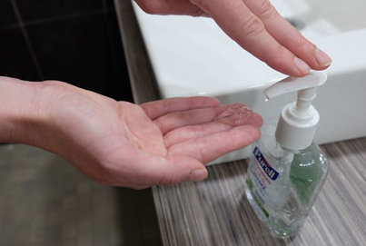  4 | 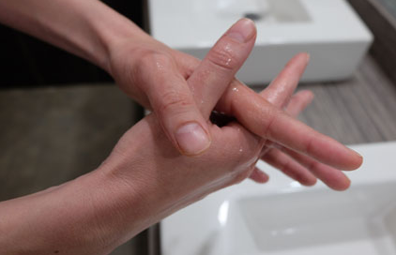  5 | (image) | 6 | 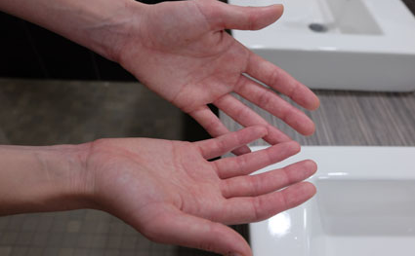  (image)
Use one squirt of hand sanitizer  [your text here] |  | Rub all over front and back of hands, wrists and fingernails  [your text here] | 6 | Allow hands to dry  [your text here]

