

Repacking
and
Wholesaling
Generic HACCP Model for Fresh Fruits and Vegetables

Edition Eight 2021

CanadaGAP Program
245 Menten Place, Suite 312
Ottawa, Ontario, Canada K2H 9E8

 |  | Title: Form 1 – Product Description
FORM 1

PRODUCT DESCRIPTION
Market product*: Includes fresh fruits, vegetables and fresh herbs in market ready packaging materials including product received from producers, packers, wholesalers, or returned to the facility.

1. Product Name | Market Product*:
2. Important Product Characteristics | Product specific (e.g. high acidity for fruits, high surface area for leafy greens, netted rind for cantaloupe)  Water activity 0.85-1.0.
3. End Use | Ready-to-eat  Consumed raw.  Cook as ingredient in recipes
4. Packaging | (From new and/or post consumer materials)  - Wooden/Fibreboard Containers (e.g., baskets, crates, bins)  - Plastic Containers (e.g., baskets, crates, bins, lugs, totes, pails, boxes, bags, trays)  - Cardboard (waxed and plain) Containers (e.g., boxes, baskets)  - Cloth Containers (e.g., bags)  - Paper Containers (i.e., bags, waxed)  - Styrofoam Containers (i.e. boxes, trays)  - Oxygen permeable packaging film  - Packaging Accessories  Including reusable containers
5. Shelf life | Varies depending on commodity and storage conditions (see links below):  https://archive.org/details/commercialstorag00cana  https://foodsafety.wisc.edu/assets/pdf_Files/Storage_Temperature_Vege.pdf  http://www.omafra.gov.on.ca/english/crops/facts/storage_berries.htm  http://www.fao.org/3/ae075e/ae075e15.htm  http://postharvest.ucdavis.edu/files/230191.pdf  https://www.ars.usda.gov/ARSUserFiles/oc/np/CommercialStorage/CommercialStorage.pdf  Mushrooms - handled at room temperature.
6. How & Where it will be sold | Sell to wholesale, food service sector (e.g. Hotel Restaurant Institution), processors, retail, restaurants, institutions and other manufacturers.  Population could include vulnerable groups such as infants, young children, pregnant, elderly and immuno-compromised people
7. Labelling instructions | Compliant with fresh fruit & vegetables regulations  CFIA Chapter 2 Basic Labelling Requirements  http://www.inspection.gc.ca/english/fssa/labeti/guide/tab2e.shtml  http://www.inspection.gc.ca/english/fssa/labeti/guide/ch2e.shtml#a2_2  Safe Food for Canadians Regulations, Section 11  https://laws-lois.justice.gc.ca/PDF/SOR-2018-108.pdf
8. Transportation and Special distribution control | Proper temperature and humidity control if applicable;  https://archive.org/details/commercialstorag00cana  https://foodsafety.wisc.edu/assets/pdf_Files/Storage_Temperature_Vege.pdf  http://www.omafra.gov.on.ca/english/crops/facts/storage_berries.htm  http://www.fao.org/3/ae075e/ae075e15.htm  http://postharvest.ucdavis.edu/files/230191.pdf  https://www.ars.usda.gov/ARSUserFiles/oc/np/CommercialStorage/CommercialStorage.pdf
*Refers to whole fruits and vegetable, excluding sprouts; fresh fruits and vegetables packaged in hermetically sealed containers and minimally processed fresh fruits and vegetables.

“Minimally Processed Produce (CFIA Definition)
Minimally processed ready-to-eat vegetables consisting of raw vegetables that have been peeled, sliced, chopped or shredded prior to being packaged for sale in Canada. Applicable products include shredded lettuce, shredded cabbage, mixed vegetable salads, ground broccoli, peeled baby carrots, chopped garlic etc. Packaging includes single serving containers (e.g., sealed pouches or plastic trays), larger consumer or institutional size packages and bulk containers. With the possible exception of the addition of dressing or croutons by the end-user, the products do not require further preparation before consumption
Products for which this code does not apply include fresh vegetables that have been trimmed only and sliced potatoes or other vegetables that are destined for cooking (e.g., French fries). Manufacturers of products that are prepared and consumed on the premises the same day (e.g., restaurants and delicatessens) are exempted from this standard.”

 | Title: Form 2 – List of Product Ingredients and Incoming Materials
FORM 2
LIST OF PRODUCT INGREDIENTS AND
INCOMING MATERIALS

Market Product |  | Other Ingredients
- Market Product (B, C, P) (Includes fresh fruits, vegetables and fresh herbs in market ready packaging materials including product received from producers, packers, wholesalers, or returned to the facility.) |  | - Ice (B, C, P)
Packaging Materials & Accessories |  | Other Incoming Materials
- Packaging Materials (from new and/or post consumer materials) including reusable and/or returnable containers (including (RPC) “Returnable and/or Reusable Plastic Containers”)  (B, C, P)  - Wooden (e.g., baskets, quarts, crates, bins, lugs, pallet boxes)  - Fibreboard Containers (e.g., baskets, quarts, crates, bins, lugs, pallet boxes)  - Plastic Containers (e.g., baskets, quarts, pints, crates, bins, lugs, totes, pails, boxes, clam shells, bags, pallet boxes, trays)  - Bags (cello/plastic/vexar) (e.g. Polypropylene (PP), Oriented Polypropylene (OPP), polyethylene terephthalate (PET), Polylactic acid (PLA), high density polyethylene (HDPE), Polylactic acid (PHA), Polyhydroxyalkanoates (PHAs), poly-3-hydroxybutyrate (PHB), polyhydroxyvalerate (PHV), polyhydroxyhexanoate (PHH), Polybutylene succinate (PBS), polycaprolactone (PCL))  - Food wrap: (e.g. polyvinyl chloride (PVC), polypropylene (PP))  - Cardboard (waxed and plain) Containers (e.g., boxes, quarts, pints, totes, baskets, masters)  - Cloth Containers [i.e., bags (jute, burlap, etc.)]  - Paper Containers (i.e., bags, waxed)  - Styrofoam Containers (i.e. pints, trays)  - Oxygen permeable packaging film  - Packaging Accessories (B, C, P)  - Packaging Accessories (i.e., bags, liners, ties and tags, metal clips, elastics, trays, wrap, glue, adhesives, dividers, wood slats, staples, stickers, inks, absorbent (vegetable) pads, labels, waxed paper, mesh/netting, tape, twine) |  | - Water treatment aids (e.g. chlorine, hydrogen peroxide, peracetic acid) (C)  - Transport and storage aids (e.g. ethylene pads, nitrogen, ozone, sulfur dioxide pads) (C)  - Water (B,C) From all sources including municipal, well, surface and third party purchases  - Other Materials - examples of these materials include citric acid, chlorine dioxide, calcium, etc. (B,C)

Title: Form 3 – Repacking and Wholesaling Flow Diagram
This multi-operational Flow diagram is a guideline to be adapted and developed to the specific operations of individual operations, verified on-site to ensure it represents the correct steps and their corresponding order in the operation
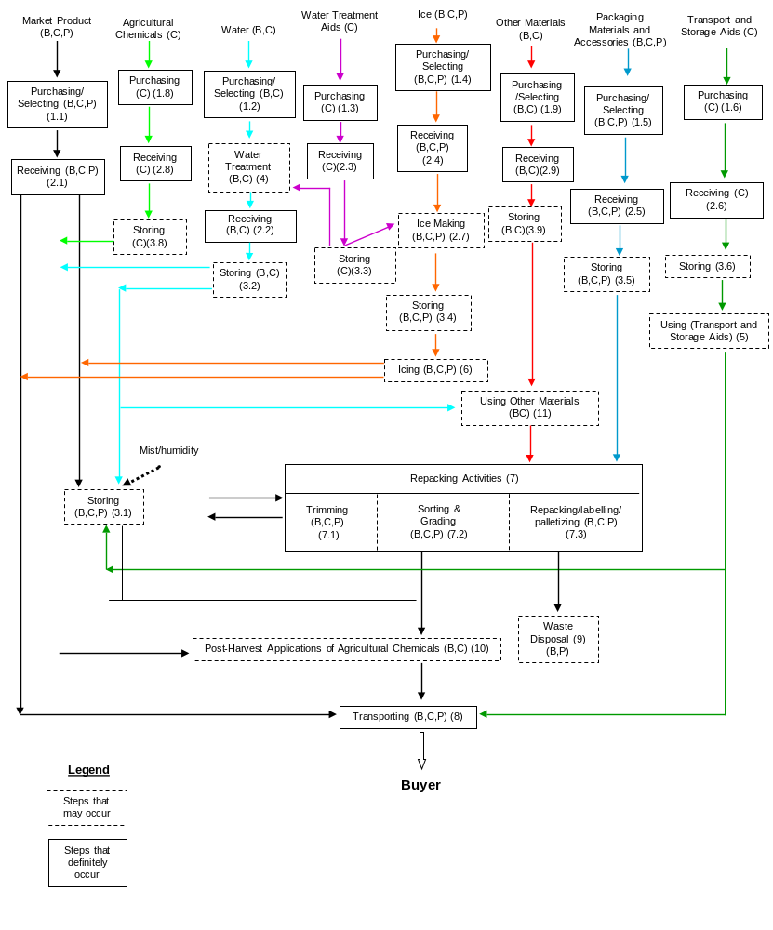

Title: Form 4 – Operation Diagram
The diagram below is a generic sample only. Each wholesale and repacking operation is unique in its layout. Each wholesaler/repacker will draw a diagram specific to his/her farm/location (Refer to Appendix V – Repacking and Wholesale Generic HACCP Model Workbook)

Instructions:
Each wholesaler/repacker will draw a site specific diagram indicating location of product, packaging materials and locations of any potential sources of cross-contamination that exist on the premises. These include other operations not in the scope of the program such as food processing or handling and storage of non-produce items such as raw meats, seafood, allergens (e.g. nuts, wheat) etc. if they occur on the premises. The wholesaler/repacker will also identify employee traffic to identify potential points of cross contamination. Note: If these additional hazards exist, additional control measure must be taken to prevent cross contamination. Additional control measures include:
- Physical separation or barriers
- Controlling or restricting employee movement between areas
- Separation of time and or space (e.g. time between receiving market product and receiving other potential sources of cross contamination or receiving these products in a different location)
- Training employees on proper procedures to prevent cross contamination such as changing clothing, footwear and other work effects and washing hands between areas
- Using dedicated equipment that does not travel between areas or having a cleaning and sanitizing procedure in place to prevent cross contamination.
Refer to Section 2. Premises and Section 12. Employee Training in the CanadaGAP Food Safety Manual and Appendix V: Repacking and Wholesale Generic HACCP Model Workbook – An Example for more information

Sample Operation Diagram



